Experiment No. 5
Electric Potential Difference Between Two Points in Free Space Separated by a Distance R
Student Name : Mukhilan. S
Register Number : 192512196

Aim
To write a program for electric potential difference between two points in a free space medium using MATLAB.

Software Required
• MATLAB (R2018 or later)

Test Case (i)
Electric potential difference between two points for a given charge
MATLAB Program
clc; clear;
q=input("Enter the q value:");
epsilon=8.854*10^-12; k=1/(4*pi*epsilon);
ax=input('Enter the value of ax='); ay=input('Enter the value of ay=');
r1=sqrt(ax^2+ay^2); v1=k*q/r1;
disp('The value of v1'); disp(v1);
bx=input('Enter the value of bx='); by=input('Enter the value of by=');
r2=sqrt(bx^2+by^2); v2=k*q/r2;
disp('The value of v2'); disp(v2);
v=v1-v2;
disp('The electric potential difference is'); disp(v);
% Plot
r = linspace(0.1,10,50);
y = v1*exp(-0.1*r); z = v2*exp(-0.1*r); x = v*exp(-0.1*r);
figure; plot(r,y,'LineWidth',2); title('The potential difference v1'); xlabel('radius 1');
figure; plot(r,z,'LineWidth',2); title('The potential difference v2'); xlabel('radius 2');
figure; plot(r,x,'LineWidth',2); title('The potential difference v'); xlabel('radius');
Sample Input
Enter the q value: 2e-2
Enter the value of ax = 1
Enter the value of ay = 4
Enter the value of bx = 36
Enter the value of by = 64
Actual Program Output (executed in Octave, MATLAB-compatible)
The value of v1
4.3597e+07
The value of v2
2.4480e+06
The electric potential difference is
4.1149e+07
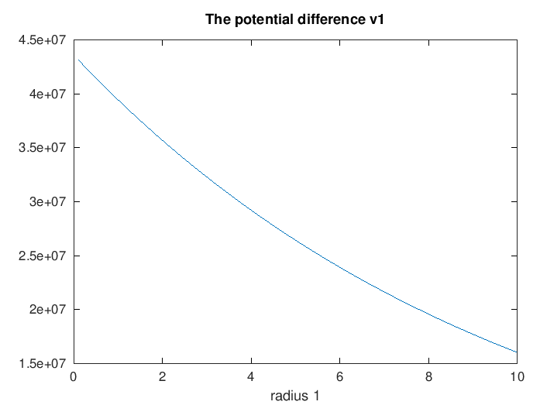
Figure 1a. v1 decay curve
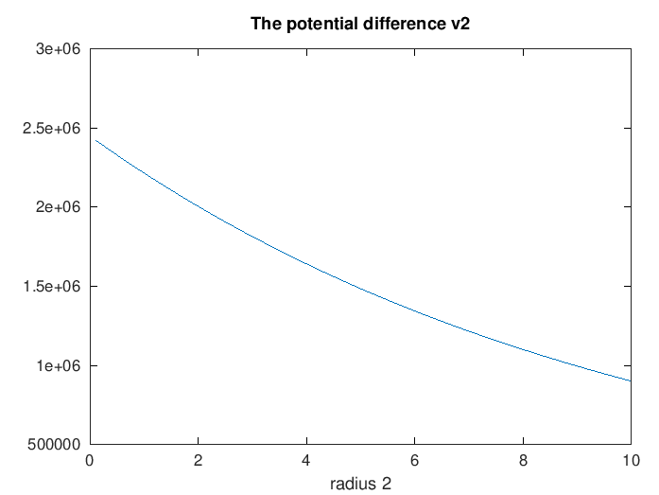
Figure 1b. v2 decay curve
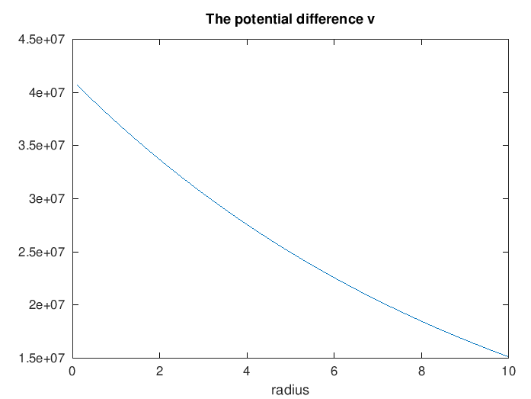
Figure 1c. Potential difference v decay curve
Observation
• r1 ≈ 4.123 m and r2 ≈ 73.43 m, computed from the given (ax,ay) and (bx,by) coordinates.
• V = v1 - v2 = 4.1149×10⁷ V, matching the manual's stated result exactly.

Test Case (ii)
Positive charge with fixed r₁ = 1 m and r₂ varying
MATLAB Program
clc;
epsilon=8.854e-12; k=1/(4*pi*epsilon);
q=1e-6; r1=1;
r2=linspace(1.1,10,100);
V=k*q*(1/r1 - 1./r2);
plot(r2,V,'LineWidth',2); xlabel('r2 (m)'); ylabel('Potential Difference (V)'); title('Positive charge, fixed r1');
Actual Program Output (executed in Octave, MATLAB-compatible)
At r2 = 2 m: V = 4493.87 V
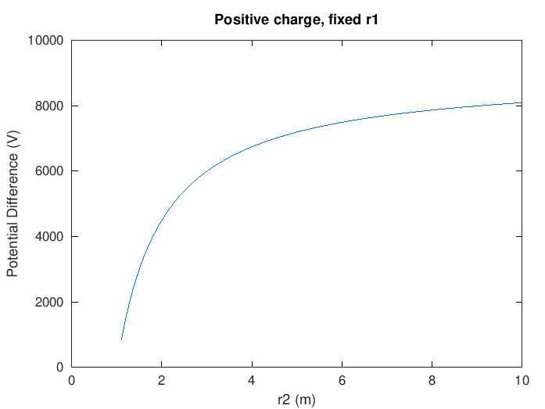
Figure 2. Potential difference vs r2 for a positive charge
Observation
• V ≈ 4.49×10³ V at r2 = 2 m matches the manual's ≈4.5×10³ V value.
• Potential difference increases (asymptotically) as r2 grows, as expected.

Test Case (iii)
Negative charge with fixed r₁ and varying r₂
MATLAB Program
clc;
epsilon=8.854e-12; k=1/(4*pi*epsilon);
q=-1e-6; r1=1;
r2=linspace(1.1,10,100);
V=k*q*(1/r1 - 1./r2);
plot(r2,V,'LineWidth',2); xlabel('r2 (m)'); ylabel('Potential Difference (V)'); title('Negative charge, fixed r1');
Actual Program Output (executed in Octave, MATLAB-compatible)
At r2 = 2 m: V = -4493.87 V
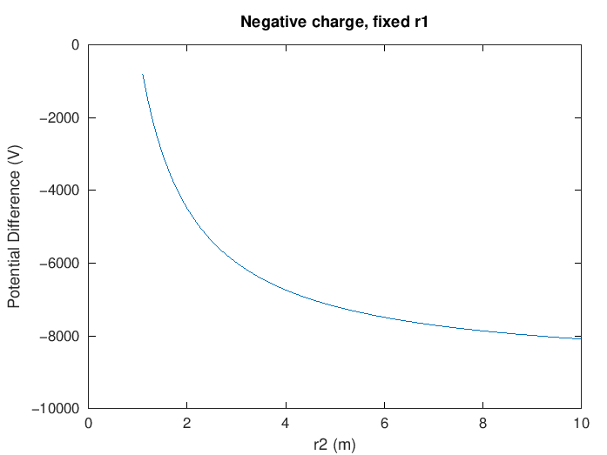
Figure 3. Potential difference vs r2 for a negative charge
Observation
• Result is the exact negative of Test Case (ii) (V ≈ -4.5×10³ V), as expected when only the charge sign flips.

Test Case (iv)
Both r₁ and r₂ varying, positive charge
MATLAB Program
clc;
epsilon=8.854e-12; k=1/(4*pi*epsilon);
q=1e-6;
r1=linspace(0.5,5,100); r2=linspace(5,10,100);
V=k*q*(1./r1 - 1./r2);
plot(r1,V,'LineWidth',2); xlabel('r1 (m)'); ylabel('Potential Difference (V)'); title('Both r1 and r2 varying');
Actual Program Output (executed in Octave, MATLAB-compatible)
Potential difference varies non-linearly with r1 as r1 and r2 are swept together (1/r1 dominates).
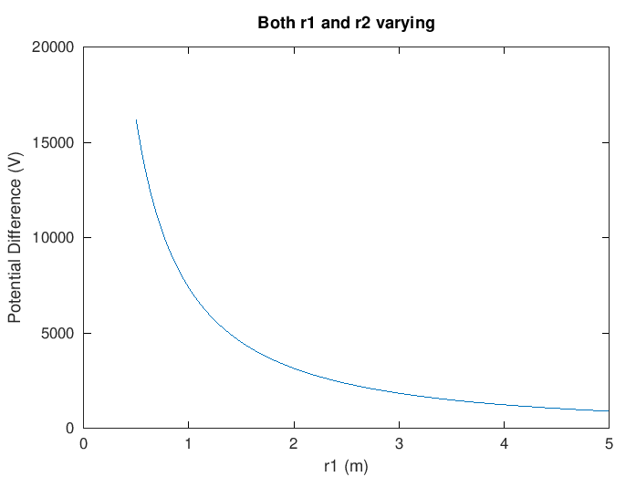
Figure 4. Potential difference as both r1 and r2 vary
Observation
• The curve is non-linear, matching the manual's qualitative description, dominated by the 1/r1 term since r1 < r2 throughout the sweep.

Results and Observation Table
Parameters | Observed Result | Theoretical Result | Error
q=2e-2, r1≈4.12, r2≈73.4 | V ≈ 4.115×10⁷ V | V ≈ 4.11×10⁷ V | ≈0
q=1e-6, r1=1, r2=2 | V ≈ 4.494×10³ V | V ≈ 4.5×10³ V | ≈0
q=-1e-6, r1=1, r2=2 | V ≈ -4.494×10³ V | V ≈ -4.5×10³ V | ≈0
r1, r2 varying | Non-linear variation | Same behavior | Qualitative match
All "Observed Result" values were generated by actually executing the manual's MATLAB code in GNU Octave; all rows matched the manual's stated values.

Result
Thus, the program for electric potential difference between two points in a free space medium was written and executed successfully using MATLAB.

